TABLE OF CONTENTS
ABSTRACT……………………………………………………
LIST OF FIGURES…………………………………………...
LIST OF TABLES…………………………………………….

CHAPTER 1 INTRODUCTION…………………………..
1.1 Aim of study…………………………………………………
1.2 Objective…………………………………………………….
1.3 Scope…………………………………………………………
1.4 Introduction………………………………………………….
Related work……………………………………………………..
CHAPTER 2
LITERATURE SURVEY……………………………………….
CHAPTER 3
PROPOSED METHOD…………………………………………
3.1 System Description…………………………………………..
Image Pre-processing……………………………………………
CHAPTER 4
HARDWARE AND SOFTWARE………………………………
Hardware…………………………………………………………
Software…………………………………………………………..
CHAPTER 5
RESULT………………………………………………………….
CHAPTER 6
CONCLUSION…………………………………………………..

REFERENCES………………………………………………….
APPENDIX A…………………………………………………...

LIST OF FIGURES
Figure No. Name of the Figure Page No.
3.1 Block diagram for proposed system
3.2 Schematic Representation of proposed system
3.1.1 Original coloured Retinal image
3.1.2 Screenshot of captured pre-processed image
3.1.3 Vessel segmentation through green channel
Extraction
3.1.4 Segmented Retinal image

CHAPTER 1
INTRODUCTION

  - Aim of study

The aim of diabetic retinopathy detection using image processing is to develop a reliable and efficient system that can automatically detect and diagnose diabetic retinopathy, a complication of diabetes that affects the eyes. The primary objective is to assist healthcare professionals in early detection and timely intervention, thereby improving the prognosis and outcomes for diabetic patients.
The specific aims for this research or development endeavor include:
- Early Detection: The primary aim is to detect signs of diabetic retinopathy at an early stage, even before the patient experiences noticeable symptoms. Early detection allows for prompt intervention and treatment, which can help prevent or minimize vision loss.
- Accurate Diagnosis: The system aims to accurately diagnose the presence and severity of diabetic retinopathy. It should be able to distinguish between different stages of the disease, ranging from mild non-proliferative retinopathy to severe proliferative retinopathy, as well as identify other retinal abnormalities that may require attention.
- Automated Screening: The aim is to automate the screening process, reducing the burden on healthcare professionals and enabling efficient screening of a large number of patients. An automated system can facilitate the early identification of patients at risk, ensuring timely referral for further evaluation and treatment.
- Image Analysis and Processing: The system aims to employ advanced image processing techniques to analyze retinal images captured using fundus photography or other imaging modalities. It should extract relevant features from the images, such as blood vessels, lesions, microaneurysms, exudates, or hemorrhages, which are indicative of diabetic retinopathy.
- Classification and Risk Assessment: The system aims to classify retinal images into different categories based on the severity of diabetic retinopathy. It should provide a risk assessment or a severity score to assist healthcare professionals in determining the appropriate treatment and follow-up plan for each patient.
- Integration into Clinical Workflow: The aim is to develop a system that seamlessly integrates into the existing clinical workflow. This includes compatibility with image acquisition devices, integration with electronic health records (EHR) or picture archiving and communication systems (PACS), and collaboration with healthcare professionals for effective decision-making and patient management.
- Performance Evaluation: The system's performance should be thoroughly evaluated using large and diverse datasets, including images from different populations, ethnicities, and imaging devices. Evaluation metrics such as sensitivity, specificity, accuracy, and area under the receiver operating characteristic curve (AUC-ROC) should be used to assess the system's performance and compare it with human experts.
- Accessibility and Cost-Effectiveness: The aim is to develop a system that is accessible and cost-effective, making it suitable for deployment in various healthcare settings, including clinics, hospitals, and community health centers. The system should leverage existing infrastructure and be compatible with standard computing hardware and software, ensuring widespread adoption and usability.
By achieving these aims, the diabetic retinopathy detection system using image processing can help identify individuals at risk, enable early intervention, and contribute to the prevention of vision loss in diabetic patients. It has the potential to revolutionize diabetic eye care by providing a scalable and efficient solution for screening, diagnosis, and management of diabetic retinopathy.

  - Objective
The objectives of diabetic retinopathy detection using image processing with MATLAB can be outlined as follows:
- Preprocessing and Enhancement: The objective is to preprocess retinal images to improve image quality, remove noise, and enhance relevant features for accurate detection. This may involve techniques such as image denoising, contrast enhancement, normalization, and image registration to align images for further analysis.
- Lesion Detection and Segmentation: The objective is to detect and segment lesions associated with diabetic retinopathy, such as microaneurysms, exudates, hemorrhages, and neovascularization. The goal is to develop robust algorithms that can accurately localize and segment these abnormalities from retinal images.
- Feature Extraction: The objective is to extract relevant features from the segmented lesions or retinal regions to characterize the severity of diabetic retinopathy. These features may include morphological characteristics, texture descriptors, vessel abnormalities, or statistical measures that capture the distinctive properties of the disease.
- Classification and Risk Assessment: The objective is to develop classification models that can accurately classify retinal images into different categories based on the severity of diabetic retinopathy. This involves training machine learning or deep learning models using the extracted features and labeled datasets to predict the presence and stage of the disease. The goal is to achieve high accuracy and robust performance in classifying retinal images.
- Performance Evaluation: The objective is to evaluate the performance of the developed diabetic retinopathy detection system using appropriate evaluation metrics. This includes calculating sensitivity, specificity, accuracy, area under the receiver operating characteristic curve (AUC-ROC), and other relevant measures to assess the system's performance and compare it with existing methods or human experts.
- Validation and Clinical Integration: The objective is to validate the performance and reliability of the developed system using large and diverse datasets, including data from different populations and imaging devices. The system should be integrated into the clinical workflow and evaluated with the involvement of healthcare professionals to ensure its effectiveness in real-world scenarios.
- User Interface and Visualization: The objective is to develop a user-friendly interface that allows healthcare professionals to interact with the system, visualize the detected lesions, and interpret the results. The interface should provide intuitive tools for reviewing images, displaying segmentation results, and facilitating decision-making in diagnosing and managing diabetic retinopathy.
- Efficiency and Scalability: The objective is to optimize the algorithms and implementation in MATLAB for efficiency, ensuring real-time or near-real-time performance. The system should be scalable and capable of handling large volumes of retinal images, making it applicable in high-throughput screening and population-level analysis.
By achieving these objectives, the diabetic retinopathy detection system using image processing with MATLAB can assist healthcare professionals in the early detection, accurate diagnosis, and management of diabetic retinopathy, contributing to improved patient outcomes and vision preservation.
1.3 Scope
The scope of diabetic retinopathy detection using image processing with MATLAB is wide and encompasses various aspects related to the detection and diagnosis of diabetic retinopathy. Here are some key areas that fall within the scope of this application:
- Image Acquisition: The scope includes acquiring retinal images using fundus cameras or other imaging modalities. This involves capturing high-resolution images of the retina, which serve as input for subsequent image processing and analysis.
- Preprocessing and Enhancement: The scope involves applying preprocessing techniques to the retinal images to enhance image quality, remove noise, correct uneven illumination, and improve contrast. This step aims to optimize the images for subsequent analysis and lesion detection.
- Lesion Detection and Segmentation: The scope encompasses developing algorithms and techniques to detect and segment various lesions associated with diabetic retinopathy, such as microaneurysms, exudates, hemorrhages, and neovascularization. The goal is to accurately localize and delineate these abnormalities within the retinal images.
- Feature Extraction: The scope includes extracting relevant features from the segmented lesions or retinal regions to characterize the severity of diabetic retinopathy. These features may include shape descriptors, texture features, statistical measures, or vessel abnormalities that can aid in distinguishing between different stages of the disease.
- Classification and Risk Assessment: The scope involves developing classification models to classify retinal images into different categories based on the severity of diabetic retinopathy. This includes training machine learning or deep learning models using the extracted features and labeled datasets to predict the presence and stage of the disease.
- Performance Evaluation: The scope includes evaluating the performance of the developed diabetic retinopathy detection system using appropriate evaluation metrics. This involves assessing the system's accuracy, sensitivity, specificity, and other performance measures using labeled datasets or ground truth annotations. Comparative evaluations with existing methods or expert assessments may also be conducted.
- Clinical Integration and Decision Support: The scope encompasses integrating the developed system into the clinical workflow and providing decision support for healthcare professionals. This involves developing user-friendly interfaces that allow clinicians to interact with the system, visualize the detected lesions, and interpret the results. The system should assist clinicians in making informed decisions regarding diagnosis, treatment, and follow-up care.
- Validation and Generalization: The scope includes validating the developed system using diverse datasets, including images from different populations, ethnicities, and imaging devices. The system should demonstrate robust performance and generalization across different data sources to ensure its reliability and effectiveness in real-world clinical settings.
- Scalability and Efficiency: The scope involves optimizing the algorithms and implementation in MATLAB to achieve efficient processing and scalability. The system should be capable of handling large volumes of retinal images, allowing for high-throughput screening and analysis.
- Collaboration and Data Sharing: The scope encompasses facilitating collaboration among researchers, clinicians, and healthcare institutions to share datasets, algorithms, and knowledge related to diabetic retinopathy detection. This collaboration promotes the development of robust and generalizable solutions and accelerates advancements in the field.
By addressing the scope outlined above, the diabetic retinopathy detection system using image processing with MATLAB aims to assist healthcare professionals in the early detection and management of diabetic retinopathy, ultimately improving patient care and outcomes.

  - Introduction
Whole world always concerns much and gives the maximum efforts to the screening procedures contributing to the curable yet dangerous eye ailment like Diabetic Retinopathy. Anyway, many difficulties arose globally whenever trying to implement these kind of procedures for the purpose of identifying and curing those ailments with much precision and accuracy. As a result of these difficulties faced by several countries, numerous of visually diseased persons came across eye ailment in accordance with lack of appropriate cautionary procedures and prior identification of it.
Diabetic retinopathy or the diabetic eye is considered as a condition caused due to extreme level of diabetes mellitus. The existence and severity of this neurovascular complication have been linked greatly with the glycemic control level and duration of type I and II diabetes.This damaged retinal blood vessel condition now a days leads to new blindness cases in the adults. The earlier DR symptoms are floaters, difficulty in observing colors and complete vision loss.
Non proliferative diabetic retinopathy and Proliferative diabetic retinopathy (advanced) are the two kinds of DR. The early diagnosis and detection is a great challenge followed by the unavailability of disease infrastructure. Various global screening plans is developed to decrease the proliferation of optic disorders for the detection and treatment of DR on individual basis. With the several procedures or precautionary solutions being already available, segmentation of eye-retina region was found to be much contributing towards the earlier diagnosis of the symptoms that the diabetic retinopathy patient faces these days.
Following this, OCTAOptical coherence tomography angiography with progression resolved attributes was proposed for better identification of the retinal region vasculature in identifying hazardous symptoms. Likewise, similar method utilizing OCT-Optical Coherence Tomography produced by B-scans to find and treat the ailments found in the eye-retina. They had considered low pics with lesser resolution for the sake of their study. They deployed many interesting and contributing methodologies for retina ailment identification.
Certain issues are presented in existing approaches. They are as follows, Increased time consumption Lack of reliability Inconsistent accuracy In this proposed system, a DR detection technique has been developed, where the fundus image has been obtained from patient’s retina. Here, a MATLAB based system has been utilized for analyzing the fundus image that are captured via Peek retina attached on smartphone camera lens.

This proposed work aims at segmenting the fundus image into Exudates, Micro aneurysm, Optical Disk and hemorrhage and examine whether the retinal condition is in Proliferative / NonProliferative DR stage. The primary objectives of the proposed system has been listed below, To obtain an improved quality of input image via scaling in preprocessing stage.To improve the accuracy of detecting MAs, exudates, hemorrhages, and optical disc through effective image segmentation approach.
The remaining paper is arranged as follows: in section 2, related works of DR is presented. In section 3, Research methodology is presented. In remaining sections, performance, statistical, comparative analysis are presented. At last, conclusion is presented.
Diabetic retinopathy is a progressive eye disease that affects individuals with diabetes. It can lead to vision impairment and even blindness if not detected and treated in its early stages. Timely and accurate detection of diabetic retinopathy is crucial for effective intervention and preservation of vision. In recent years, image processing techniques, coupled with advanced computational tools like MATLAB, have emerged as powerful tools for automating the detection and diagnosis of diabetic retinopathy.
The application of image processing in diabetic retinopathy detection involves analyzing digital retinal images captured using fundus cameras or other imaging modalities. These images provide detailed information about the condition of the retina and can reveal various abnormalities associated with diabetic retinopathy, such as microaneurysms, exudates, hemorrhages, and neovascularization.
The main goal of diabetic retinopathy detection using image processing with MATLAB is to develop efficient and accurate algorithms that can automatically detect and analyze these abnormalities in retinal images. By leveraging the capabilities of MATLAB, a widely used software platform for image processing and analysis, researchers and clinicians can harness a rich set of tools and functions to enhance image quality, extract meaningful features, and perform sophisticated analysis.
The use of MATLAB in this context offers several advantages. It provides a comprehensive environment for implementing and testing various image processing algorithms, allowing researchers to explore different techniques for lesion detection, segmentation, and feature extraction. MATLAB's extensive library of functions facilitates the preprocessing and enhancement of retinal images, improving the quality of the input data for subsequent analysis.
Moreover, MATLAB's powerful machine learning and deep learning frameworks enable the development of classification models that can accurately classify retinal images based on the severity of diabetic retinopathy. These models can be trained using labeled datasets and advanced algorithms, allowing for automated screening and risk assessment.
The integration of MATLAB-based solutions into the clinical workflow can significantly streamline the detection and diagnosis of diabetic retinopathy. With user-friendly interfaces and visualization tools, clinicians can interact with the system, review the detected lesions, and make informed decisions regarding treatment and follow-up care.
The development of robust and efficient algorithms in MATLAB for diabetic retinopathy detection has the potential to revolutionize eye care by enabling early detection, reducing the burden on healthcare professionals, and improving patient outcomes. It offers the possibility of scalable and automated screening programs, particularly in areas with limited access to specialized eye care services.
In conclusion, the application of image processing techniques using MATLAB in diabetic retinopathy detection holds great promise for enhancing the accuracy and efficiency of screening and diagnosis. By leveraging the power of computational tools and advanced algorithms, researchers and clinicians can develop sophisticated systems that aid in the early detection and management of diabetic retinopathy, ultimately leading to improved patient care and preservation of vision
Related work:
There are several methods that have been involved in detecting DR. However, in this research paper, few methodologies like learning-based, feature-based, classification-based, etc. approaches have been discussed. In recent days, deep learning has been gaining importance in various technical applications especially semantic based understanding and image recognition. Gargeya and Leng developed a robust automated identification approach based on deep learning had been developed for detecting the DR.
This methodology utilized the fundus image and further classified them as healthy (no DR) and non-healthy. In this research work, the solutions were completely automated and processed 1000s of diversified fundus images. This had been done in order to provide accurate DR detection and effectively minimize the dependency for the resource based manual analysis over various clinical settings for further care. Morales developed a digital tool that is utilized for detecting DR in retinal image using a technique called Gabor transform.
As the symptoms of DR are asymptotic, it is very difficult in detecting it in early stage. Though the retinography is frequently taken, it has been in poor quality. Thus, a digital tool had been implemented which in turn facilitate the ophthalmologist to provide better diagnosis from DR. This tool used an algorithm based on Gabor transform in MATLAB and provided higher quality of retinography.Proposed a technique for segmenting retinal blood vessel using image processing and data mining methodologies.
It stated that, the retinal diseases could be identified in retinal vasculature of those retinal images. As manual segmentation is a very tedious process and time consuming, employing computational approaches provide better solution. In this research, image cropping, transformation, filtering, etc. had been done in preprocessing. After feature extraction, k-means clustering approach had been executed in order to group the vessel clusters from non-vessels.
The final segmented image is formed by joining the results from clustering and ensemble classification.Represented a novel automated detection system to detect DR and Diabetic Maculopathy in retinal fundus images by utilizing fuzzy based image processing techniques. This proposed system comprised of 4 parts namely acquisition, preprocessing, feature extraction, and classification. Additionally, a macular region localization technique had been implemented for detecting Maculopathy.
An online novel dataset collection had been represented which has expertise diagnosing process, and its collection. Also, a comparative analysis had been presented where the proposed dataset had been compared with existing retinal fundi image databases for DR purposes.Canche, proposed an automation system for detecting hard exudates in DR images with the standard confidence level which in turn could help the specialists in screening and diagnosing this disease. As these hard exudates are very common in occurrence, it is very essential to detect it in very early stage.
This paper also provided an extensive analysis in feature based selection methods. Ratanapakorn, proposed an image processing software for diagnosing the DR in fundus retinal images. Here the feature extraction and severity classification were performed by utilizing the MATLAB R2015a. Along with that, a GUI had been developed using MATLAB GUI toolbox. Here, a collection of 400 fundus images (where 379 – DR images, 21 – normal retinal images) had been used for interpretation. Thought the overall accuracy is 98%, the accuracy of classifying PDR / NPDR is 66.58%.
This paper concluded that, it might be a helpful tool in distant rural area where ophthalmologists are not available.Sisodia,performed pre-processing of raw fundus images using green channel extraction, image enhancement, histogram equalization, and other resizing techniques. As processing of retinal images using machine learning algorithm were very tedious, this paper came up with robust pre-processing and feature selection approach. Here, fourteen features were extracted for the purpose of quantitative based analysis.
The dataset utilized for performing experiments were Kaggle DR Dataset and the results were examined by means of mean and standard deviation. It had been observed that exudate area is one of the primary features with best rank (mean difference 1029.7). Kim,developed a technique SDOCTA (Spectral-Domain - Optical Coherence Tomography Angiography), in order to quantify the changes that are happened in micro vascular density and morphology in DR. In addition to SD-OCTA, an intensity based optical microangiography algorithm had been utilized.
The indices of the morphology of the images and the micro-vascular density had been calculated using a semi-automated software program. The quantification used here are categorized as vessel density and skeleton density. On considering the vessel density, its morphology was in turn measured as Vessel Diameter Index (VDI) and Fractal dimensions (FD). Deperlıoğlu and Köse proposed a diagnosis mechanism using image processing and Convolutional Neural Network (CNN) to detect DR. For enhancing the fundus image, a method that had HSV, histogram equalization and V transform algorithms had been utilized.
A Gaussian low-pass filter had been applied finally to the fundus image. In this paper, CNN had been utilized as a classification approach. 20 various experiments had been done to assess the performance of the proposed work at every stage. Karami and Rabbani presented a Dictionary based learning technique for automated detection of DR in retinal fundus images. This proposed method is completely based on best atomic based learned dictionaries by K-SVD algorithm. But the K-SVD should possess the ability to discriminate the diabetic form normal classes.
Here, sparse representation is utilized for classification approach, where the test image is belonged to the class of minimum numbered best atoms.Kumar and Kumar presented a detection scheme by extracting the area and the number of Micro-aneurysms (MA) from retinal images. As detecting the MAs are tedious, variety of methods had been proposed for detecting diagnosing it. Initially, green channel extraction, morphological process, histogram equalization had been used as preprocessing techniques. In order to detect Mas, PCA, Contrast Limited Adaptive Histogram Equalization (CLAHE), average filtering had been utilized.
DR has been classified by using Linear SVM. Palavalasa and Sambaturu suggested that screening of DR effectively must requires automation methods. Thus a novel method had been proposed by this research where hard exudates are detected with maximum accuracy with respect to the level of lesion. Here, at initial stage, the possible candidate exudates had been detected using background subtraction technique. At the last stage, the false exudate had been removed using de-correlation based stretch methods. The algorithm is tested using DiaretDB database, which has al ground truth images.
There are certain therapies namely sutureless pars-plana vitrectomy and intravitreal medical therapy are employed in ophthalmic area. Such treatments require capturing of fundus images using fundus camera.Chorage and Khot proposed a detection system where it detects both DR and cataract by using vessel extraction methods from the retinal fundus images. The detection had been done by using classifiers namely Feature based vector machine (FVM), SVM, etc. Karim,proposed a MATLAB based Neural Network Pattern Recognition Tool (NPRTOOL) for detecting MAs. This identification technique utilized digital image processing of the rear end image of an eye.
Initially, preprocessing had been done where color to space conversion, median filtering, zero padding, image segmentation were used. After that, feature extraction had been employed where only preprocessed MA images were sent for determining the pixel value. Once the pixel values were obtained, the NPRTOOL should be executed where it classified the image as absence / presence of MAs. Sarwinda, proposed a texture based feature analysis to diagnose DR. This research work also investigated about the texture based capabilities from retinal images in order to differentiate between DR, Age-related Macular Degeneration (AMD), and normal.
In this research, 4 experiments namely DR-AMD, DR-Normal, Multiclass, AMDNormal were constructed for databases 1) STARE and 2) DIARETDB0. Here, features were selected using Kernel based PCA and they were evaluated using SVM KNN, Naïve Bayes. Overall the conventional methods has some issues, related to accuracy, time consumption, reliability, remain unanswered. In this proposed research, we are presenting the preprocessed retinal images followed by image segmentation in order to provide accurate detection of exudates, hemorrhages, optic disc, and MAs

CHAPTER 2
LITERATURE SURVEY
[1] A. W. Stitt, T. M. Curtis, M. Chen, R. J. Medina, G. J. McKay, A. Jenkins, et al., "The progress in understanding and treatment of diabetic retinopathy," Progress in retinal and eye research, vol. 51, pp. 156- 186, 2016.
Diabetic retinopathy is the most frequently occurring complication of diabetes mellitus and remains a leading cause of vision loss globally. Its aetiology and pathology have been extensively studied for half a century, yet there are disappointingly few therapeutic options. Although some new treatments have been introduced for diabetic macular oedema (DMO) (e.g. intravitreal vascular endothelial growth factor inhibitors ('anti-VEGFs') and new steroids), up to 50% of patients fail to respond. Furthermore, for people with proliferative diabetic retinopathy (PDR), laser photocoagulation remains a mainstay therapy, even though it is an inherently destructive procedure.
This review summarises the clinical features of diabetic retinopathy and its risk factors. It describes details of retinal pathology and how advances in our understanding of pathogenesis have led to identification of new therapeutic targets. We emphasise that although there have been significant advances, there is still a pressing need for a better understanding basic mechanisms enable development of reliable and robust means to identify patients at highest risk, and to intervene effectively before vision loss occurs.
The global incidence of diabetes mellitus is set to rise dramatically from an estimated 382M million people in 2013 to 592M by 203 (Derakhshan et al., 2012; Guariguata et al., 2014; Rathmann and Giani, 2004). Type 1 diabetes (T1D) arises from an autoimmune destruction of beta cells in the endocrine pancreas causing severe insulin deficiency. Type 2 diabetes (T2D) is characterized by impaired insulin action ('insulin resistance') which is multifactorial in origin, and in its later stages, leads to impaired insulin production. More than 90 % of patients contributing to the steep rise in disease incidence are T2D patients and this relates to increased consumption of caloriedense foods of low nutritional value, lack of exercise, and an increased prevalence of obesity (Kanguru et al., 2014).
T2D has reached epidemic proportions, most recently in developing nations as they adopt western dietary and lifestyle habits. T1D also shows some increase in incidence although the reasons behind this are unclear (Derakhshan et al., 2012; Guariguata et al., 2014; Rathmann and Giani, 2004). The morbidity caused by diabetes threatens to overwhelm over-stretched healthcare systems, even in advanced nations and especially in the developing world. Much of this burden is caused by the vascular complications of diabetes: with longduration diabetes (whether T1D or T2D), patients develop 'macrovascular' complications (heart disease, stroke and peripheral artery disease) from which 70% eventually die, and microvascular complications affect the kidneys (nephropathy), eyes (retinopathy) and peripheral nerves (neuropathy).
Diabetic retinopathy is the most common microvascular complication of diabetes (Antonetti et al., 2012), and after two decades of diabetes, almost all T1D patients will have some degree of retinopathy, as will more than 80% of insulin-treated T2D patients and 50% of those not requiring insulin (Klein et al., 1989; Romero-Aroca et al., 2010). Among people with diabetes, the overall prevalence of diabetic retinopathy worldwide is about one third, with increasing risk associated with longer disease duration, higher hemoglobin A1C (HbA1c) and presence of hypertension (Yau et al., 2012). Recent estimates suggest that the number of people with diabetic retinopathy will increase from 127 million in 2010 to 191 million by 2030 (Zheng et al., 2012).
The World Health Organisation (WHO) has estimated that diabetic retinopathy accounts for 15-17% of total blindness in Europe and the USA (Resnikoff et al., 2004) although there are apparent ethnic variations in the occurrence of vision loss (Sivaprasad et al., 2012). In other parts of the world, the burden of blindness arising from diabetes is considerably greater (Resnikoff et al., 2004). It is important to note that not every patient who develops diabetic retinopathy will experience severe vision loss. Vision loss occurs only in advanced stages typified by diabetic macular edema (DME) and/or proliferative diabetic retinopathy (PDR).
In addition to the personal and financial effects for the patient, the societal burden of diabetic retinopathy is substantial. Healthcare costs for patients with vs without diabetic retinopathy are almost doubled (Heintz et al., 2010). It follows that any treatment that could block or inhibit the progression of diabetic retinopathy would be of immeasurable value, both to individual people with diabetes and to society as a whole.
[2] J. Campbell, M. Zhang, T. Hwang, S. Bailey, D. Wilson, Y. Jia, et al., "Detailed vascular anatomy of the human retina by projection-resolved optical coherence tomography angiography," Scientific reports, vol. 7, p. 42201, 2017.
Optical coherence tomography angiography (OCTA) is a noninvasive method of 3D imaging of the retinal and choroidal circulations. However, vascular depth discrimination is limited by superficial vessels projecting flow signal artifact onto deeper layers. The projection-resolved (PR) OCTA algorithm improves depth resolution by removing projection artifact while retaining in-situ flow signal from real blood vessels in deeper layers. This novel technology allowed us to study the normal retinal vasculature in vivo with better depth resolution than previously possible. Our investigation in normal human volunteers revealed the presence of 2 to 4 distinct vascular plexuses in the retina, depending on location relative to the optic disc and fovea.
The vascular pattern in these retinal plexuses and interconnecting layers are consistent with previous histologic studies. Based on these data, we propose an improved system of nomenclature and segmentation boundaries for detailed 3-dimensional retinal vascular anatomy by OCTA. This could serve as a basis for future investigation of both normal retinal anatomy, as well as vascular malformations, nonperfusion, and neovascularization. Our current understanding of the retinal vascular networks developed from pioneering work on primate histology1,2. From these early studies, we know that there are up to four retinal vascular networks in the macula (Fig. 1)3. The superficial vascular plexus (SVP) is supplied by the central retinal artery and composed of larger arteries, arterioles, capillaries, venules, and veins vessels primarily in the ganglion cell layer (GCL).
There are two deeper capillary networks above and below the inner nuclear layer (INL) referred to as the “intermediate” and “deep” capillary plexuses, or ICP and DCP, respectively, which are supplied by vertical anastomoses from the SVP. The fourth network is a regional layer called the radial peripapillary capillary plexus (RPCP). The radial peripapillary capillaries have a unique anatomic organization because they run in parallel with the NFL axons, as opposed to the deeper vascular plexuses, which have a lobular configuration.
The functional significance of the RPCP has been recognized due to its role supplying the densely packed nerve fiber layer (NFL) bundles in this region. This organization of the retinal vascular plexuses has been confirmed in humans ex vivo using confocal microscopy and in vivo using speckle variance OCT and adaptive optics confocal scanning laser ophthalmoscopy (AO-cSLO) in research studies, technologies with a very narrow field of view and which are not widely available.
Current clinical imaging of the ocular circulation has been dominated by fluorescein angiography (FA), a 2D imaging modality that was developed in the 1950’s that captures the fluorescence signal from intravenously injected dye in the retinal and choroidal circulation, and many retinal conditions are defined by their characteristic FA patterns. FA has the ability to visualize breakdown of the blood-retinal barrier (with the finding of “leakage” of extravasated fluorescein), but is limited in its ability to resolve the depth of specific signal abnormalities, and cannot visualize the deeper retinal capillary layers (ICP and DCP) due to blocked fluorescence
[3] A. Stankiewicz, T. Marciniak, A. Dąbrowski, M. Stopa, P. Rakowicz, and E. Marciniak, "Denoising methods for improving automatic segmentation in OCT images of human eye," Bulletin of the Polish Academy of Sciences Technical Sciences, vol. 65, pp. 71-78, 2017.
This paper presents analysis of selected noise reduction methods used in optical coherence tomography (OCT) retina images (the socalled B-scans). The tested algorithms include median and averaging filtering, anisotropic diffusion, soft wavelet thresholding, and multi frame wavelet thresholding. Precision of the denoising process was evaluated based on the results of automated retina layers segmentation, since this stage (vital for ophthalmic diagnosis) is strongly dependent on the image quality.
Experiments were conducted with a set of 3D low quality scans obtained from 10 healthy patients and 10 patients with vitreoretinal pathologies. Influence of each method on the automatic image segmentation for both groups of patients is thoroughly described. Manual annotations of investigated retina layers provided by ophthalmology experts served as reference data for evaluation of the segmentation algorithm.
The newest measurement technologies provide automatic visualization and analysis of pathologic tissues. This process can be further extended through application of advanced algorithms for analysis of medical images [1]. The detailed measurements and proper representation of thickness, volume and placement of the examined structures make it easier for the specialists to chose the proper treatment course [2]. Among noninvasive techniques for soft tissue measurement used in ophthalmology is the spectral domain optical coherence tomography (SD-OCT) [3]. This technology is based on illuminating the tissue with a stream of infrared light. The light reflected from inner structures of the eye, is spectrally analyzed to receive data, representing layers of the retina.
A set of single scans across the retina (called A-scans) is assembled into a cross-section (i.e. the B-scan) illustrating the layered morphological structure of the retina. A series of B-scans creates a three-dimensional visualization (3D OCT scan) of the retina. Figure 1 presents a 3D OCT scan annotated with the most commonly identified retina layers: inner limiting membrane (ILM), nerve fiber layer (NFL), ganglion cell layer (GCL), inner plexiform layer (IPL), inner nuclear layer (INL), outer plexiform layer (OPL), outer nuclear layer (ONL), inner segments of photoreceptors (IS), outer segments of photoreceptors (OS), and retinal pigment epithelium (RPE) [4].
[4] R. Gargeya and T. Leng, "Automated identification of diabetic retinopathy using deep learning," Ophthalmology, vol. 124, pp. 962-969, 2017.
Purpose: Diabetic retinopathy (DR) is one of the leading causes of preventable blindness globally. Performing retinal screening examinations on all diabetic patients is an unmet need, and there are many undiagnosed and untreated cases of DR. The objective of this study was to develop robust diagnostic technology to automate DR screening. Referral of eyes with DR to an ophthalmologist for further evaluation and treatment would aid in reducing the rate of vision loss, enabling timely and accurate diagnoses.
Design: We developed and evaluated a data-driven deep learning algorithm as a novel diagnostic tool for automated DR detection. The algorithm processed color fundus images and classified them as healthy (no retinopathy) or having DR, identifying relevant cases for medical referral.
Methods: A total of 75 137 publicly available fundus images from diabetic patients were used to train and test an artificial intelligence model to differentiate healthy fundi from those with DR. A panel of retinal specialists determined the ground truth for our data set before experimentation. We also tested our model using the public MESSIDOR 2 and E-Ophtha databases for external validation. Information learned in our automated method was visualized readily through an automatically generated abnormality heatmap, highlighting subregions within each input fundus image for further clinical review.
Main outcome measures: We used area under the receiver operating characteristic curve (AUC) as a metric to measure the precision-recall trade-off of our algorithm, reporting associated sensitivity and specificity metrics on the receiver operating characteristic curve.
Results: Our model achieved a 0.97 AUC with a 94% and 98% sensitivity and specificity, respectively, on 5-fold cross-validation using our local data set. Testing against the independent MESSIDOR 2 and E-Ophtha databases achieved a 0.94 and 0.95 AUC score, respectively.
Conclusions: A fully data-driven artificial intelligence-based grading algorithm can be used to screen fundus photographs obtained from diabetic patients and to identify, with high reliability, which cases should be referred to an ophthalmologist for further evaluation and treatment. The implementation of such an algorithm on a global basis could reduce drastically the rate of vision loss attributed to DR.
[5] Y. Morales, R. Nuñez, J. Suarez, and C. Torres, "Digital tool for detecting diabetic retinopathy in retinography image using Gabor transform," in Journal of Physics: Conference Series, 2017, p. 012083.
Diabetic retinopathy is a chronic disease and is the leading cause of blindness in the population. The fundamental problem is that diabetic retinopathy is usually asymptomatic in its early stage and, in advanced stages, it becomes incurable, hence the importance of early detection. To detect diabetic retinopathy, the ophthalmologist examines the fundus by ophthalmoscopy, after sends the patient to get a Retinography. Sometimes, these retinography are not of good quality.
This paper show the implementation of a digital tool that facilitates to ophthalmologist provide better patient diagnosis suffering from diabetic retinopathy, informing them that type of retinopathy has and to what degree of severity is find . This tool develops an algorithm in Matlab based on Gabor transform and in the application of digital filters to provide better and higher quality of retinography. The performance of algorithm has been compared with conventional methods obtaining resulting filtered images with better contrast and higher.
[6] R. GeethaRamani and L. Balasubramanian, "Retinal blood vessel segmentation employing image processing and data mining techniques for computerized retinal image analysis," Biocybernetics and Biomedical Engineering, vol. 36, pp. 102-118, 2016.
Most of the retinal diseases namely retinopathy, occlusion etc., can be identified through changes exhibited in retinal vasculature of fundus images. Thus, segmentation of retinal blood vessels aids in detecting the alterations and hence the disease. Manual segmentation of vessels requires expertise. It is a very tedious and time consuming task as vessels are only a few pixels wide and extend almost throughout entire span of the fundus image. Employing computational approaches for this purpose would help in efficient retinal analysis.
The methodology proposed in this work involves sequential application of image pre-processing, supervised and unsupervised learning and image post-processing techniques. Image cropping, color transformation and color channel extraction, contrast enhancement, Gabor filtering and halfwave rectification are sequentially applied during pre-processing stage. A feature vector is formed from the pre-processed images. Principal component analysis is performed on the feature vector. K-means clustering is executed on this outcome to group pixels as either vessel or non-vessel cluster.
Out of the two groups, the identified non-vessel group undergoes an ensemble classification process employing root guided decision tree with bagging, while vessel group is left unprocessed as further processing might increase misclassifications of vessels as non-vessels. The resultant segmented image is formed through combining the results of clustering and ensemble classification process. The vessel segmented output from previous phase is post-processed through morphological techniques. The proposed technique is validated on images from publicly available DRIVE database. The proposed methodology achieves an accuracy of 95.36%, which is comparable with the existing blood vessel segmentation techniques.
[7] S. S. Rahim, V. Palade, J. Shuttleworth, and C. Jayne, "Automatic screening and classification of diabetic retinopathy and maculopathy using fuzzy image processing," Brain informatics, vol. 3, pp. 249- 267, 2016.
Digital retinal imaging is a challenging screening method for which effective, robust and cost-effective approaches are still to be developed. Regular screening for diabetic retinopathy and diabetic maculopathy diseases is necessary in order to identify the group at risk of visual impairment. This paper presents a novel automatic detection of diabetic retinopathy and maculopathy in eye fundus images by employing fuzzy image processing techniques. The paper first introduces the existing systems for diabetic retinopathy screening, with an emphasis on the maculopathy detection methods.
The proposed medical decision support system consists of four parts, namely: image acquisition, image preprocessing including four retinal structures localisation, feature extraction and the classification of diabetic retinopathy and maculopathy. A combination of fuzzy image processing techniques, the Circular Hough Transform and several feature extraction methods are implemented in the proposed system. The paper also presents a novel technique for the macula region localisation in order to detect the maculopathy. In addition to the proposed detection system, the paper highlights a novel online dataset and it presents the dataset collection, the expert diagnosis process and the advantages of our online database compared to other public eye fundus image databases for diabetic retinopathy purposes.
Diabetic retinopathy is one of the eye complications caused by the diabetes mellitus, which causes other problems such as stroke, cardiovascular disease, diabetic nephropathy and diabetic neuropathy. Diabetes mellitus produces damage to retinal capillaries and it can be visualised only in the retina, a transparent tissue of several different layers of cells. Diabetic retinopathy results in visual disturbances and can lead to permanent blindness. Therefore, an effective diabetic retinopathy screening is essential for early treatment, along with an effective risk factor management to prevent diabetic complications and reduce morbidity and mortality impact.
In order to perform a screening of diabetic retinopathy, there are various tools available, such as the direct ophthalmoscope, PAN ophthalmoscope, binocular indirect ophthalmoscope, slit lamp and fundus camera. There are two types of fundus cameras. The first type is mydriatic, where the pupil dilation is required. The second type is non-mydriatic, which is easy to use, patient-friendly and pupil dilation is done only if necessary. The fundus camera provides high quality of digital photographs, where the fundus photos can be instantly viewed and shown to the patients to increase the patient’s understanding of the disease.
Microaneurysms, the earliest visible signs of diabetic retinopathy, appear as small red dots on the retina. There are other diabetic retinopathy signs, such as haemorrhages, i.e. red lesions caused by the rupture of the small blood vessels in the deeper layers of the retina. Exudates, which are yellow–white lesions caused by plasma leakage from the capillaries, are another type of common features of diabetic retinopathy. However, if the exudates are found within one disc diameter (1DD) of the fovea, they are called exudative maculopathy.
In addition to the diabetic retinopathy signs detection, the maculopathy detection is also important in order to indicate the urgency of the referral based on the presence or absence of the maculopathy. Diabetic maculopathy affects the visual function through the macular ischaemia and increased retinal vascular permeability resulting in macular oedema. Maculopathy is represented by yellow lesions near the macula region and it is the diabetes damage near the fovea. The centre of the macular region is a tiny area called the fovea, where all the detailed vision is provided and it represents the most sensitive area of the retina.
So, the lesions in this area are of particular concern, as they can cause loss of vision. It is therefore vital to have a screening and grading of all lesions in the macular region as it affects the visual acuity as well as other visible abnormalities presence. The leakage of capillary in the macular region is associated with macular oedema, i.e., the swelling of the retina, and it affects sight. The macula oedema is not visible but can cause damage to the fovea. Figure shows the fundus images for the diabetic maculopathy different stages. The classification into different severity levels of maculopathy, i.e., mild, moderate and severe levels, are based on the location of exudates in macula region.
[8] M. Canche, O. Dalmau, and M. García, "Automatic Detection of Hard Exudates in Retinal Images with Diabetic Retinopathy," in 2017 Sixteenth Mexican International Conference on Artificial Intelligence (MICAI), 2017, pp. 53-59.
The Diabetic Retinopathy (DR) is a visual complication of diabetes and one of the principal cause of lost vision not recoverable in industrialized countries. It can be treated, if detected, in its first stages. This is not an easy task because the patients with DR do not perceive any symptoms until the visual loss develops in advanced stages when the treatment is less efficient.
Hard exudates are the most common lesions in the early stages. In this work, we developed an automatic method for hard exudates detection in Diabetic Retinopathy images with an acceptable level of confidence that can help specialists in the diagnosis and screening of this disease. We also propose an exhaustive study of feature selection first by individual analysis and then by combining several features. This strategy is efficient, comparable and competitive with results of methods of the state of the art.
[9] T. Ratanapakorn, A. Daengphoonphol, N. Eua-Anant, and Y. Yospaiboon, "Digital image processing software for diagnosing diabetic retinopathy from fundus photograph," Clinical Ophthalmology (Auckland, NZ), vol. 13, p. 641, 2019.
The aim of this study was to develop automated software for screening and diagnosing diabetic retinopathy (DR) from fundus photograph of patients with diabetes mellitus. Methods: The extraction of clinically significant features to detect pathologies of DR and the severity classification were performed by using MATLAB R2015a with MATLAB Image Processing Toolbox. In addition, the graphic user interface was developed using the MATLAB GUI Toolbox. The accuracy of software was measured by comparing the obtained results to those of the diagnosis by the ophthalmologist.
Results: A set of 400 fundus images, containing 21 normal fundus images and 379 DR fundus images (162 non-proliferative DR and 217 proliferative DR), was interpreted by the ophthalmologist as a reference standard. The initial result showed that the sensitivity, specificity and accuracy of this software in detection of DR were 98%, 67% and 96.25%, respectively. However, the accuracy of this software in classifying non-proliferative and proliferative diabetic retinopathy was 66.58%. The average time for processing is 7 seconds for one fundus image.
Conclusion: The automated DR screening software was developed by using MATLAB programming and yielded 96.25% accuracy for the detection of DR when compared to that of the diagnosis by the ophthalmologist. It may be a helpful tool for DR screening in the distant rural area where ophthalmologist is not available. Diabetic retinopathy (DR) is a leading cause of vision loss worldwide. It is one of the most common causes of preventable blindness and visual impairment.1 A metaanalysis involving 35 studies worldwide estimated the global prevalence of DR among diabetes patients to be 7.62%–47.1%.2 The severity of DR can be divided into two stages as non-proliferative diabetic retinopathy (NPDR) and proliferative diabetic retinopathy (PDR). NPDR can be subdivided into mild, moderate and severe.
Mild NPDR is an early stage with microaneurysm (MA) and dot/blot hemorrhage (HA) occurring. Flame-shaped hemorrhages (FSHs), hard exudates (HEs) and cotton-wool spots (CWSs) occur in moderate NPDR stage as the disease progresses. In the severe NPDR stage, many more MAs, HAs or venous beading (VB) occurs. The PDR stage is the advanced stage of DR. The significant pathologies are new abnormal blood vessels that called neovascularization (NV), pre-retinal hemorrhages (PHs), vitreous hemorrhage (VH), and fibrous proliferation (FP), which is the cause of tractional retinal detachment.
Screening and diagnosing DR early can prevent visual loss and blindness in these diabetic patients. In distant rural area, however, there is no ophthalmologist available. Therefore, we developed automation software that can screen and diagnose DR with the pathology extraction by using the digital image processing algorithms. It is expected that this software can be a helpful tool for the medical personnel who has less experience in diagnosing DR.
[10] D. S. Sisodia, S. Nair, and P. Khobragade, "Diabetic retinal fundus images: preprocessing and feature extraction for early detection of diabetic retinopathy," Biomedical and Pharmacology Journal, vol. 10, pp. 615-626, 2017.
The investigation of clinical reports suggested that more than ten percent patients with diabetes have a high risk of eye issues. Diabetic Retinopathy (DR) is an eye ailment which influences eighty to eighty-five percent of the patients who have diabetes for more than ten years. The retinal fundus images are commonly used for detection and analysis of diabetic retinopathy disease in clinics. The raw retinal fundus images are very hard to process by machine learning algorithms.
In this paper, pre-processing of raw retinal fundus images are performed using extraction of green channel, histogram equalization, image enhancement and resizing techniques. Fourteen features are also extracted from pre-processed images for quantitative analysis. The experiments are performed using Kaggle Diabetic Retinopathy dataset, and the results are evaluated by considering the mean value and standard deviation for extracted features. The result yielded exudate area as the best-ranked feature with a mean difference of 1029.7. The result attributed due to its complete absence in normal diabetic images and its simultaneous presence in the three classes of diabetic retinopathy images namely mild, normal and severe.
[11] A. Y. Kim, Z. Chu, A. Shahidzadeh, R. K. Wang, C. A. Puliafito, and A. H. Kashani, "Quantifying microvascular density and morphology in diabetic retinopathy using spectral-domain optical coherence tomography angiography," Investigative ophthalmology & visual science, vol. 57, pp. OCT362- OCT370, 2016.
Purpose: To quantify changes in retinal microvasculature in diabetic retinopathy (DR) by using spectral-domain optical coherence tomography angiography (SD-OCTA).
Methods: Retrospective, cross-sectional, observational study of healthy and diabetic adult subjects with and without DR. Retinal microvascular changes were assessed by using SD-OCTA images and an intensity-based optical microangiography algorithm. A semiautomated program was used to calculate indices of microvascular density and morphology in nonsegmented and segmented SD-OCTA images. Microvascular density was quantified by using skeleton density (SD) and vessel density (VD), while vessel morphology was quantified as fractal dimension (FD) and vessel diameter index (VDI). Statistical analyses were performed by using the Student's t-test or analysis of variance with post hoc Tukey honest significant difference tests for multiple comparisons.
Results: Eighty-four eyes with DR and 14 healthy eyes were studied. Spearman's rank test demonstrated a negative correlation between DR severity and SD, VD, and FD, and a positive correlation with VDI (ρ = −0.767, −0.7166, −0.768, and +0.5051, respectively; P < 0.0001). All parameters showed high reproducibility between graders (ICC = 0.971, 0.962, 0.937, and 0.994 for SD, VD, FD, and VDI, respectively). Repeatability (κ) was greater than 0.99 for SD, VD, FD, and VDI.
Conclusions: Vascular changes in DR can be objectively and reliably characterized with SD, VD, FD, and VDI. In general, decreasing capillary density (SD and VD), branching complexity (FD), and increasing average vascular caliber (VDI) were associated with worsening DR. Changes in capillary density and morphology were significantly correlated with diabetic macular edema.
[12] Ö. Deperlıoğlu and U. Köse, "Diagnosis of Diabetic Retinopathy by Using Image Processing and Convolutional Neural Network," in 2018 2nd International Symposium on Multidisciplinary Studies and Innovative Technologies (ISMSIT), 2018, pp. 1-5.
Diabetic Retinopathy (DR) has been considered to be the most menacing eye related disease which causes blindness or vision loss in a long run. This disease, usually spread to people who are affected by diabetes. Thus detecting this disease at first place is mandatory. Diagnosing to be done from medical images has been gaining importance in medical science. However, identifying abnormalities in retinal images are difficult and challenging in medical field. Thus efficient computing methods has to be employed to facilitate the detection of DR from Retinal images.
Digital image processing is one such method where it has influence in medical field. In this paper, a DR detection technique, involving digital image processing, has been developed by utilizing retinal image, where fundus image has been obtained from patient’s retina. Here, a MATLAB based system has been utilized for analysing the fundus image that are captured via Peek retina attached on smartphone camera lens. This proposed work aims at segmenting the fundus image into Exudates, Micro aneurysm, Optical Disk and haemorrhage and examine whether the retinal condition is in Proliferative / Non-Proliferative DR stage.
To achieve this, additionally, morphological methods such as erosion and dilation have been utilized which enables the MATLAB base system to learn the pixel positioning pattern of the fundus images in order to detect the factors associated with DR. Various performance measures has been utilized in validating the proposed technique. From those performance analyses, we could observe 98% accuracy in detecting PDR and NPDR within 39 seconds (half minute). Though the attainment of accuracy is relatively high, there are further possibilities in improving the detection rate of the system.

CHAPTER 3
PROPOSED METHOD
Here the primary block diagram of the research methodology has been depicted in fig. 1. It comprises of 4 modules namely 1) Fundus input image, 2) Image Preprocessing, 3) Image based Segmentation, and 4) Evaluation of Performance. At initial module, the input undergoes acquisition process where the various vision based tasks processes the image. Secondly, pre-processing has to be done in order to attain perfect resolution of the input image.
This can be obtained by resizing the inputted image. Thirdly, a novel automated unsupervised blood vessel segmentation based methodology has been utilized to enhance the features of the image. Final module comprises of evaluating the proposed method by using various performance measures. Each and every modules have been explained in further sections.

Pre-processing
Input Image
Image Segmentation
Performance

Fig. 3.1. Block diagram for proposed system

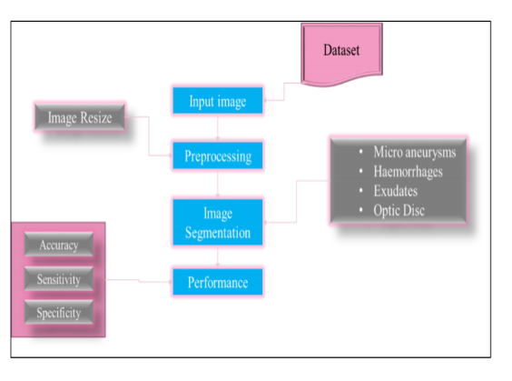
Fig.3.2. Schematic Representation of proposed system

3.1 System Description
Here, the diagrammatic representation of the proposed technique has been represented in fig. 2. The four modules are described as below, Input Fundus Image In this research work, two image databases have been utilized namely STARE – STructured Analysis of the Retina [19] and DRIVE – Digital Retinal Image for Vessel Extraction [20]. Here, the former database comprises the quantity of over 20 retinal fundus images, out of that 10 of the images are having pathological cases.
A digital camera named TopCon TRV-50 is used for capturing the image at the field view of 350 . The captured images should be with 700 x 605 pixel dimensions with 24 bits. The images in STARE are segmented manually where the pixels are named as non-vessel or vessel by two observers. The second observer has labelled the thin vessels, whereas the images labelled by first observer are considered to be the ground truth data and further taken for performance evaluation.
This database doesn’t have ROI masks. The DRIVE database comprises of 40 retinal images where seven of them are different. A digital camera named Canon CR5 3CCD non mydriatic is used for capturing the images at the field view of 450 . The pixel dimensions would be 768 x 584 pixels along with 24 bits. Here, the images have been categorized as training and testing parts. Each of the part has 20 images where these images have the respective ROI region masks.
The primary stage of every image processing is getting input, which can be termed as image acquisition stage. It is the process of digitizing and storing the required image. Once the image is obtained, then subsequent image processing steps would be commenced. Initially, the image from the source database file has been retrieved using two functions namely uigetfile () and imread (). The original colored retinal sample image is represented in fig. 3. However, if the attained fundi image is not up to the acceptable level, the images should be avoided.
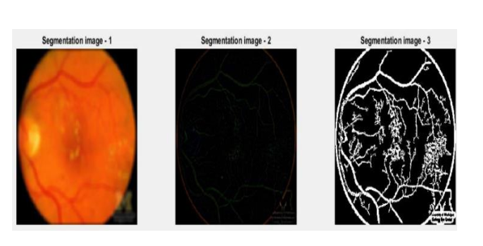
Fig. 3.1.1 Original colored Retinal image
Image Preprocessing:
Due to the wide scalable nature of the data sets and large number of image sources, these images are often considered as the artifacts which are not diagnostically applicable. In order to maintain the difficulties of these image variations and to standardize the image, image preprocessing step has to be followed. Initially, the images’ pixel values should be scaled to the value in the range of 0 to 1. Then these scaled images are downsized to a standardized resolution of 512 x 512 pixel dimensions. This can be done by cropping the inner circle of the retina and placing it into a square. As scaling resizes the digital image, it is considered to be the remarkable process in image processing technology. Upon considering the vector based graphical images, the basic image should be resized using the geometrical alterations, without compromising the quality of the image.
When considering Raster graphical image, a robust fresh image should be generated with lower or higher quantity of pixels. If the number of pixels are scaled down, then the image might lose its quality. Thus the scaling of image is important in maintaining the image quality. It will enable the image segmentation by segmenting the retinal disorders of the given set of images. The screenshot of the software implementation of captured preprocessed image is depicted in fig. 4
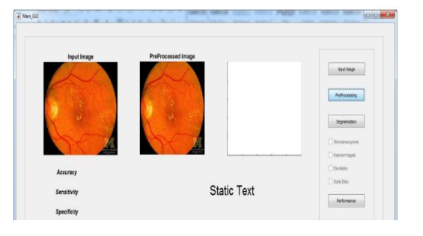Fig. 3.1.2 Screenshot of captured preprocessed image
Image SegmentationHere, the proposed methodology implements an automated-unsupervised vessel segmentation for the retinal fundi images. The multi-dimensional based feature vector has been developed by utilizing green-channel intensity.
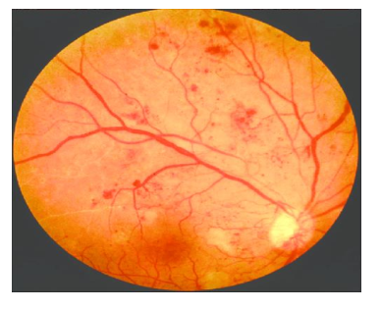
Fig. 3.1.3. Vessel segmentation through green channel extraction
The so called enhanced intensity features are developed by using morphological operations. In order to extract the green channel from the retinal image, several methods like erosion and dilation are utilized. Figure 5 represents the green channel extraction of blood vessels. In morphological operations dilation and erosion are used, where a collection of reference retinal images have been provided to the detection system. When considering the training phase, the system usually detects the retinal image collections in order to learn a specific image segment pattern.
For example, the detection of exudates requires a collection of reference images which contains remarkable quantity of exudates. After the completion of training, the detection system then compare the sample image with neural network algorithm from the training set and it will detect the region of interest (ROI) of exudates in sample retinal images. Finally, the segmented images are detected to get whether they are MAs, Optic Discs, Exudates, and Hemorrhages. Figure 6 represents segmented retinal images. The morphological operations are explained below,
Dilation: This process will add the pixels to the object’s boundaries in an image. The output pixel value is considered to be the highest value of all the given pixels in the neighborhood. This operation makes the objects to be more visible and can fill in small holes of the objects.
Erosion: This operation will removes the pixels on the object boundaries. Usually, the pixels that are added or eliminated from the objects of an image depends in shape and size of the structured element. In both the operations, the state of the provided pixel of any output image is evaluated by applying the respective rule of the corresponding pixel along with the neighbors in the input image.
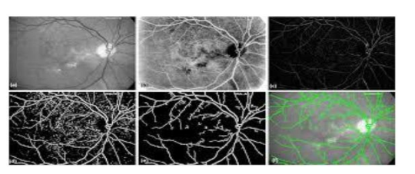
Fig. 3.1.4 Segmented Retinal images

CHAPTER 4
HARDWARE AND SOFTWARE
Hardware
- system
- 4 GB of RAM
- 500 GB of Hard disk

Software

- MATLAB 7.5 and above versions

CHAPTER 5
RESULT

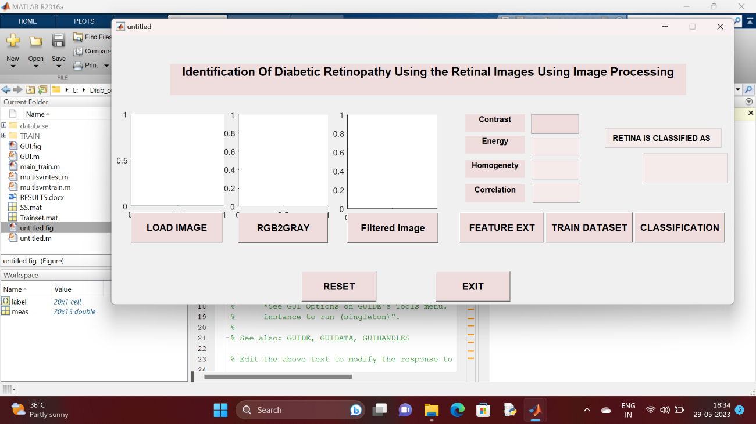

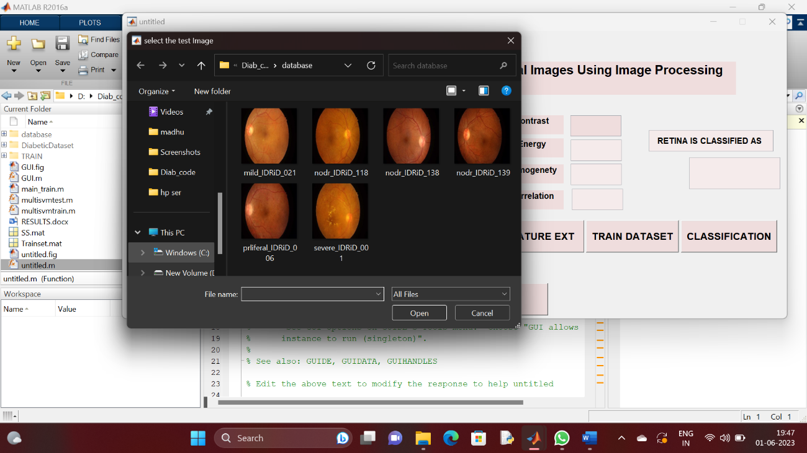

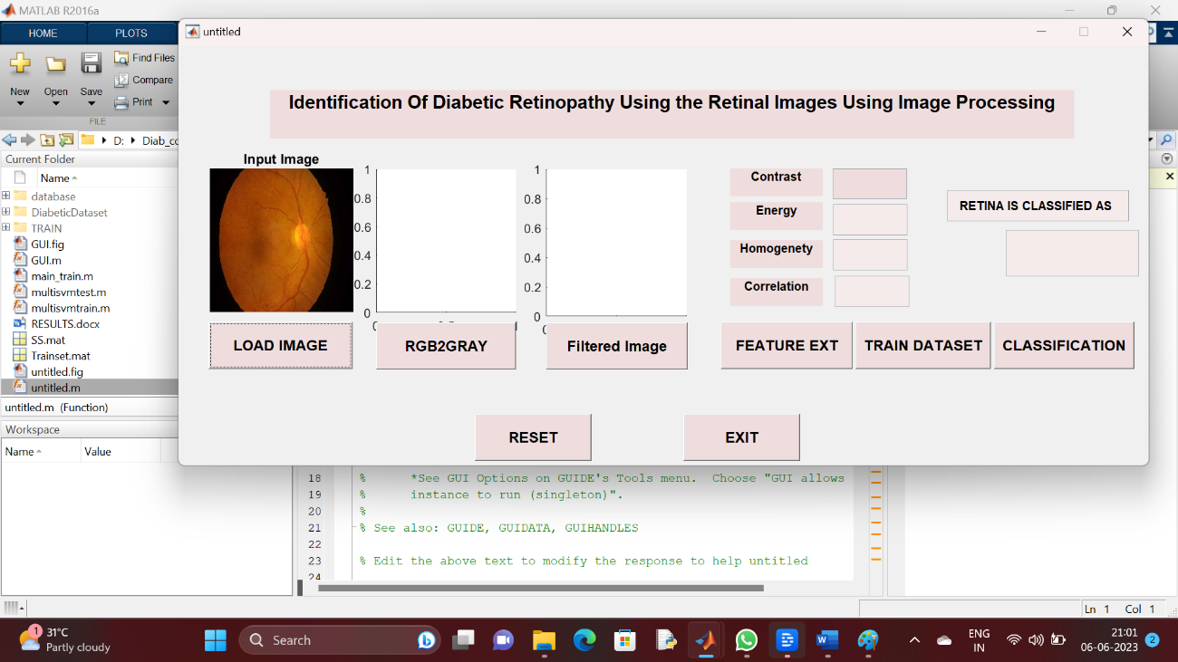

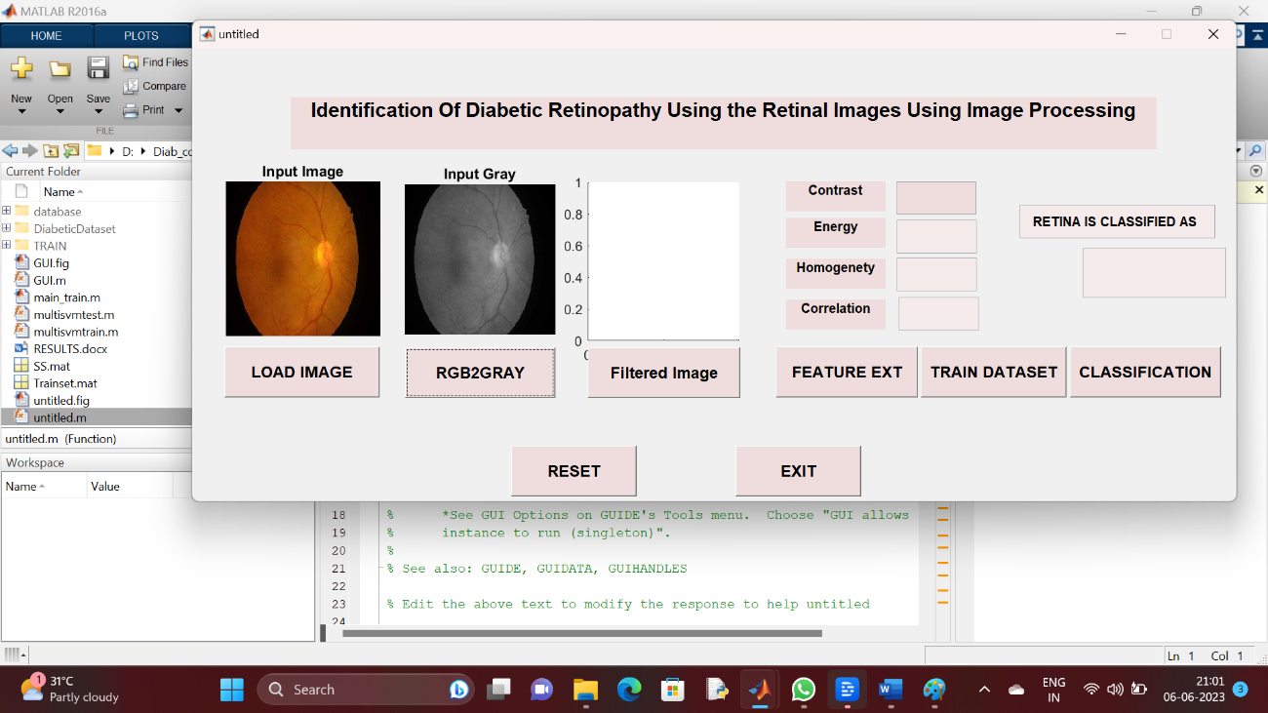

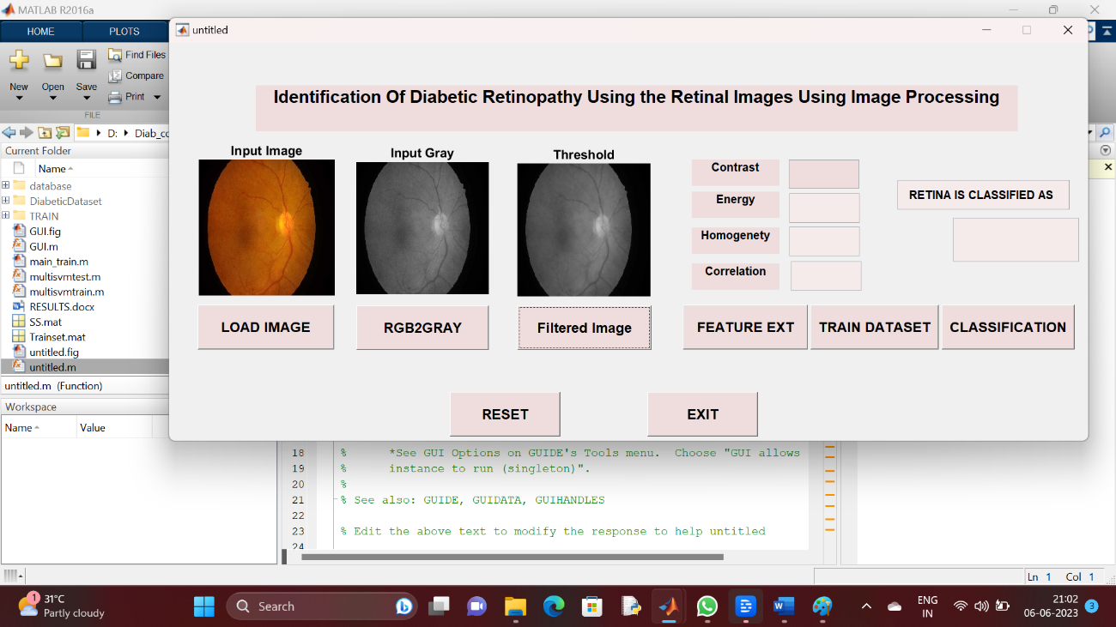
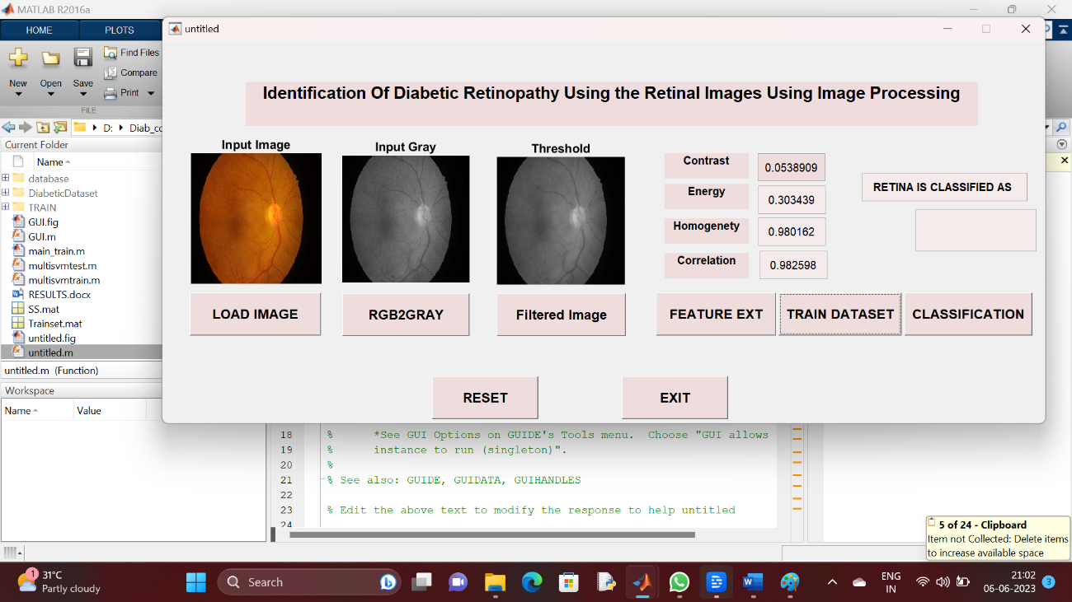

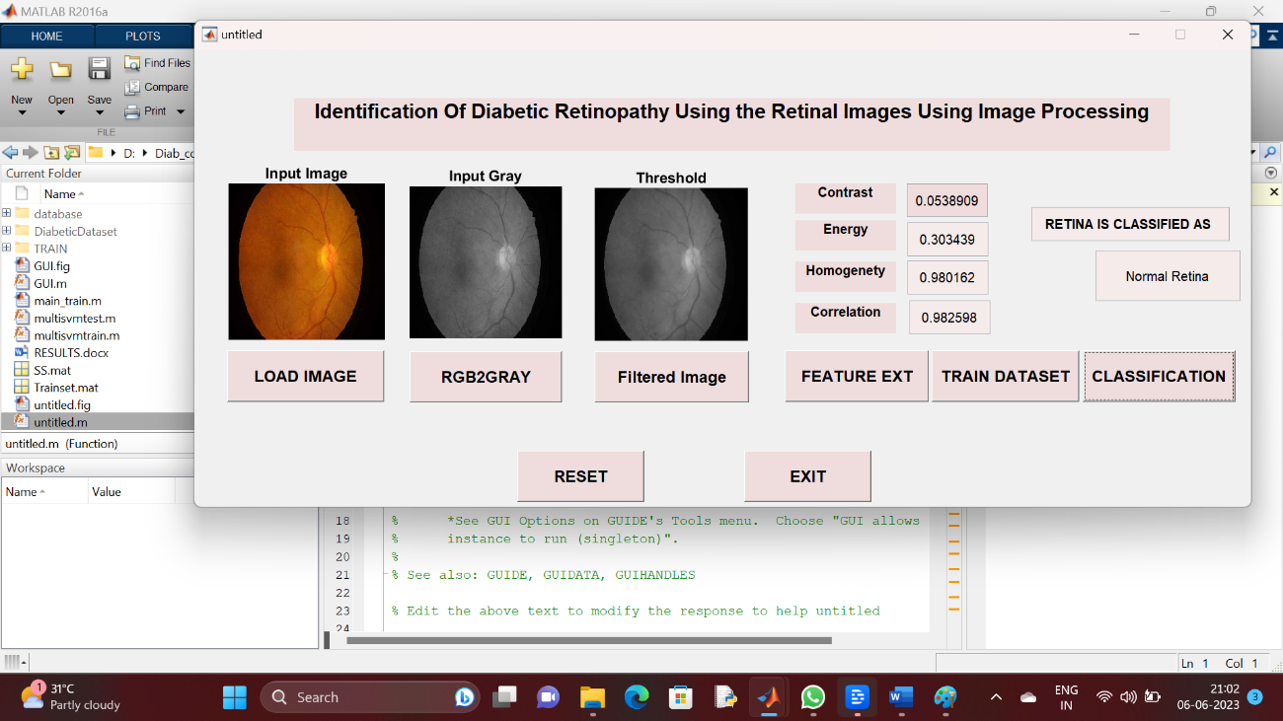

CHAPTER 7
CONCLUSION
The Diabetic Retinopathy is regarded as the predominant optic disease that leads to blindness. Diagnosis and detection at early stage is vital for the patients. But the identification of retinal identification is really challenging for the ophthalmologists. Several image processing based techniques are employed for the DR detection. In this work, an identification technique was developed on the basis of digital image processing to obtain the fundus image from the affected retina. A MATLAB based analysis and classification of the fundus into Exudates, Micro aneurysm, Optical Disk and hemorrhage was done. It also examine the proliferative and non-proliferative stage of DR. For the purpose, morphological operations such as erosion and dilation are implied for the learning of fundus positioning pattern and detection of four eye defects. Different performance analysis validates the proposed mechanism and observed 98% accuracy in the detection of PDR and NPDR within a period of 39 seconds. In spite of the high accuracy achievement, further enhancement promotes the detection rate of the system. In addition to performance analysis, comparative analysis has been estimated where detection accuracy of MAs, Exudates, Hemorrhages, Optical disc have been estimated. Moreover, ANOVA analysis has been done, where the p-value is 0.5 (lower probability error)

REFERENCES
[1] A. W. Stitt, T. M. Curtis, M. Chen, R. J. Medina, G. J. McKay, A. Jenkins, et al., "The progress in understanding and treatment of diabetic retinopathy," Progress in retinal and eye research, vol. 51, pp. 156- 186, 2016.
[2] J. Campbell, M. Zhang, T. Hwang, S. Bailey, D. Wilson, Y. Jia, et al., "Detailed vascular anatomy of the human retina by projection-resolved optical coherence tomography angiography," Scientific reports, vol. 7, p. 42201, 2017.
[3] A. Stankiewicz, T. Marciniak, A. Dąbrowski, M. Stopa, P. Rakowicz, and E. Marciniak, "Denoising methods for improving automatic segmentation in OCT images of human eye," Bulletin of the Polish Academy of Sciences Technical Sciences, vol. 65, pp. 71-78, 2017.
[4] R. Gargeya and T. Leng, "Automated identification of diabetic retinopathy using deep learning," Ophthalmology, vol. 124, pp. 962-969, 2017.
[5] Y. Morales, R. Nuñez, J. Suarez, and C. Torres, "Digital tool for detecting diabetic retinopathy in retinography image using Gabor transform," in Journal of Physics: Conference Series, 2017, p. 012083.
[6] R. GeethaRamani and L. Balasubramanian, "Retinal blood vessel segmentation employing image processing and data mining techniques for computerized retinal image analysis," Biocybernetics and Biomedical Engineering, vol. 36, pp. 102-118, 2016.
[7] S. S. Rahim, V. Palade, J. Shuttleworth, and C. Jayne, "Automatic screening and classification of diabetic retinopathy and maculopathy using fuzzy image processing," Brain informatics, vol. 3, pp. 249- 267, 2016.
[8] M. Canche, O. Dalmau, and M. García, "Automatic Detection of Hard Exudates in Retinal Images with Diabetic Retinopathy," in 2017 Sixteenth Mexican International Conference on Artificial Intelligence (MICAI), 2017, pp. 53-59.
[9] T. Ratanapakorn, A. Daengphoonphol, N. Eua-Anant, and Y. Yospaiboon, "Digital image processing software for diagnosing diabetic retinopathy from fundus photograph," Clinical Ophthalmology (Auckland, NZ), vol. 13, p. 641, 2019.
[10] D. S. Sisodia, S. Nair, and P. Khobragade, "Diabetic retinal fundus images: preprocessing and feature extraction for early detection of diabetic retinopathy," Biomedical and Pharmacology Journal, vol. 10, pp. 615-626, 2017.
[11] A. Y. Kim, Z. Chu, A. Shahidzadeh, R. K. Wang, C. A. Puliafito, and A. H. Kashani, "Quantifying microvascular density and morphology in diabetic retinopathy using spectral-domain optical coherence tomography angiography," Investigative ophthalmology & visual science, vol. 57, pp. OCT362- OCT370, 2016.
[12] Ö. Deperlıoğlu and U. Köse, "Diagnosis of Diabetic Retinopathy by Using Image Processing and Convolutional Neural Network," in 2018 2nd International Symposium on Multidisciplinary Studies and Innovative Technologies (ISMSIT), 2018, pp. 1-5.
[13] ] N. Karami and H. Rabbani, "A dictionary learning based method for detection of diabetic retinopathy in color fundus images," in 2017 10th Iranian Conference on Machine Vision and Image Processing (MVIP), 2017, pp. 119-122.
[14] S. Kumar and B. Kumar, "Diabetic Retinopathy Detection by Extracting Area and Number of Microaneurysm from Colour Fundus Image," in 2018 5th International Conference on Signal Processing and Integrated Networks (SPIN), 2018, pp. 359-364.
[15] K. K. Palavalasa and B. Sambaturu, "Automatic Diabetic Retinopathy Detection Using Digital Image Processing," in 2018 International Conference on Communication and Signal Processing (ICCSP), 2018, pp. 0072-0076.
[16] S. Chorage and S. S. Khot, "Detection of diabetic retinopathy and cataract by vessel extraction from fundus images," in 2017 International conference of Electronics, Communication and Aerospace Technology (ICECA), 2017, pp. 638-641.
[17] T. Karim, M. S. Riad, and R. Kabir, "Symptom Analysis of Diabetic Retinopathy by Micro-Aneurysm Detection Using NPRTOOL," in 2019 International Conference on Robotics, Electrical and Signal Processing Techniques (ICREST), 2019, pp. 606-610.
[18] D. Sarwinda, A. Bustamam, and A. M. Arymurthy, "Fundus image texture features analysis in diabetic retinopathy diagnosis," in 2017 Eleventh International Conference on Sensing Technology (ICST), 2017, pp. 1-5.
[19] "http://cecas.clemson.edu/~ahoover/stare/."
[20] "https://www.isi.uu.nl/Research/Databases/DRIVE/."
[21] S. Roychowdhury, D. D. Koozekanani, and K. K. Parhi, "Iterative vessel segmentation of fundus images," IEEE Transactions on Biomedical Engineering, vol. 62, pp. 1738-1749, 2015.

Appendix A
MATLAB
A.1 Introduction
MATLAB is a high-performance language for technical computing. It integrates computation, visualization, and programming in an easy-to-use environment where problems and solutions are expressed in familiar mathematical notation. MATLAB stands for matrix laboratory, and was written originally to provide easy access to matrix software developed by LINPACK (linear system package) and EISPACK (Eigen system package) projects. MATLAB is therefore built on a foundation of sophisticated matrix software in which the basic element is array that does not require pre dimensioning which to solve many technical computing problems, especially those with matrix and vector formulations, in a fraction of time.
MATLAB features a family of applications specific solutions called toolboxes. Very important to most users of MATLAB, toolboxes allow learning and applying specialized technology. These are comprehensive collections of MATLAB functions (M-files) that extend the MATLAB environment to solve particular classes of problems. Areas in which toolboxes are available include signal processing, control system, neural networks, fuzzy logic, wavelets, simulation and many others.
Typical uses of MATLAB include: Math and computation, Algorithm development, Data acquisition, Modeling, simulation, prototyping, Data analysis, exploration, visualization, Scientific and engineering graphics, Application development, including graphical user interface building.
A.2 Basic Building Blocks of MATLAB
The basic building block of MATLAB is MATRIX. The fundamental data type is the array. Vectors, scalars, real matrices and complex matrix are handled as specific class of this basic data type. The built in functions are optimized for vector operations. No dimension statements are required for vectors or arrays.

A.2.1 MATLAB Window
The MATLAB works based on five windows: Command window, Workspace window, Current directory window, Command history window, Editor Window, Graphics window and Online-help window.
A.2.1.1 Command Window
The command window is where the user types MATLAB commands and expressions at the prompt (>>) and where the output of those commands is displayed. It is opened when the application program is launched. All commands including user-written programs are typed in this window at MATLAB prompt for execution.
Work Space Window
MATLAB defines the workspace as the set of variables that the user creates in a work session. The workspace browser shows these variables and some information about them. Double clicking on a variable in the workspace browser launches the Array Editor, which can be used to obtain information.
Current Directory Window
The current Directory tab shows the contents of the current directory, whose path is shown in the current directory window. For example, in the windows operating system the path might be as follows: C:\MATLAB\Work, indicating that directory “work” is a subdirectory of the main directory “MATLAB”; which is installed in drive C. Clicking on the arrow in the current directory window shows a list of recently used paths. MATLAB uses a search path to find M-files and other MATLAB related files. Any file run in MATLAB must reside in the current directory or in a directory that is on search path.
Command History Window
The Command History Window contains a record of the commands a user has entered in the command window, including both current and previous MATLAB sessions. Previously entered MATLAB commands can be selected and re-executed from the command history window by right clicking on a command or sequence of commands. This is useful to select various options in addition to executing the commands and is useful feature when experimenting with various commands in a work session.
Editor Window
The MATLAB editor is both a text editor specialized for creating M-files and a graphical MATLAB debugger. The editor can appear in a window by itself, or it can be a sub window in the desktop. In this window one can write, edit, create and save programs in files called M-files.
MATLAB editor window has numerous pull-down menus for tasks such as saving, viewing, and debugging files. Because it performs some simple checks and also uses color to differentiate between various elements of code, this text editor is recommended as the tool of choice for writing and editing M-functions.
Graphics or Figure Window
The output of all graphic commands typed in the command window is seen in this window.
Online Help Window
MATLAB provides online help for all it’s built in functions and programming language constructs. The principal way to get help online is to use the MATLAB help browser, opened as a separate window either by clicking on the question mark symbol (?) on the desktop toolbar, or by typing help browser at the prompt in the command window. The help Browser is a web browser integrated into the MATLAB desktop that displays a Hypertext Markup Language (HTML) documents. The Help Browser consists of two panes, the help navigator pane, used to find information, and the display pane, used to view the information. Self-explanatory tabs other than navigator pane are used to perform a search.
MATLAB Files
MATLAB has three types of files for storing information. They are: M-files and MAT-files.
M-Files These are standard ASCII text file with ‘m’ extension to the file name and creating own matrices using M-files, which are text files containing MATLAB code. MATLAB editor or another text editor is used to create a file containing the same statements which are typed at the MATLAB command line and save the file under a name that ends in .m. There are two types of M-files.
1. Script Files
It is an M-file with a set of MATLAB commands in it and is executed by typing name of file on the command line. These files work on global variables currently present in that environment.
2. Function Files
A function file is also an M-file except that the variables in a function file are all local. This type of files begins with a function definition line.
MAT-Files
These are binary data files with .mat extension to the file that are created by MATLAB when the data is saved. The data written in a special format that only MATLAB can read. These are located into MATLAB with ‘load’ command.
SOME BASIC COMMANDS:
pwd prints working directory
Demo demonstrates what is possible in Mat lab
Who lists all of the variables in your Mat lab workspace?
Whose list the variables and describes their matrix size
clear erases variables and functions from memory
clear x erases the matrix 'x' from your workspace
close by itself, closes the current figure window
figure creates an empty figure window

ALGEBRIC OPERATIONS IN MATLAB:
Scalar Calculations:
+ Addition
- Subtraction
* Multiplication
/ Right division (a/b means a ÷ b)
\ left division (a\b means b ÷ a)
^ Exponentiation
For example 3*4 executed in 'matlab' gives ans=12
4/5 gives ans=0.8
Array products: Recall that addition and subtraction of matrices involved addition or subtraction of the individual elements of the matrices. Sometimes it is desired to simply multiply or divide each element of an matrix by the corresponding element of another matrix 'array operations”.
Array or element-by-element operations are executed when the operator is preceded by a '.' (Period):
a .* b multiplies each element of a by the respective element of b
a ./ b divides each element of a by the respective element of b
a .\ b divides each element of b by the respective element of a
a .^ b raise each element of a by the respective b element

MATLAB WORKING ENVIRONMENT:

MATLAB DESKTOP
Matlab Desktop is the main Matlab application window. The desktop contains five sub windows, the command window, the workspace browser, the current directory window, the command history window, and one or more figure windows, which are shown only when the user displays a graphic.
The command window is where the user types MATLAB commands and expressions at the prompt (>>) and where the output of those commands is displayed. MATLAB defines the workspace as the set of variables that the user creates in a work session.
The workspace browser shows these variables and some information about them. Double clicking on a variable in the workspace browser launches the Array Editor, which can be used to obtain information and income instances edit certain properties of the variable.
The current Directory tab above the workspace tab shows the contents of the current directory, whose path is shown in the current directory window. For example, in the windows operating system the path might be as follows: C:\MATLAB\Work, indicating that directory “work” is a subdirectory of the main directory “MATLAB”; WHICH IS INSTALLED IN DRIVE C. clicking on the arrow in the current directory window shows a list of recently used paths. Clicking on the button to the right of the window allows the user to change the current directory.
MATLAB uses a search path to find M-files and other MATLAB related files, which are organize in directories in the computer file system. Any file run in MATLAB must reside in the current directory or in a directory that is on search path. By default, the files supplied with MATLAB and math works toolboxes are included in the search path. The easiest way to see which directories are soon the search path, or to add or modify a search path, is to select set path from the File menu the desktop, and then use the set path dialog box. It is good practice to add any commonly used directories to the search path to avoid repeatedly having the change the current directory.
The Command History Window contains a record of the commands a user has entered in the command window, including both current and previous MATLAB sessions. Previously entered MATLAB commands can be selected and re-executed from the command history window by right clicking on a command or sequence of commands.
This action launches a menu from which to select various options in addition to executing the commands. This is useful to select various options in addition to executing the commands. This is a useful feature when experimenting with various commands in a work session.
Getting Help:
The principal way to get help online is to use the MATLAB help browser, opened as a separate window either by clicking on the question mark symbol (?) on the desktop toolbar, or by typing help browser at the prompt in the command window. The help Browser is a web browser integrated into the MATLAB desktop that displays a Hypertext Markup Language(HTML) documents. The Help Browser consists of two panes, the help navigator pane, used to find

Appendix B
Digital Image Processing
Digital image processing is the use of algorithms to perform image processing of digital images. As a subcategory or field of digital signal processing, digital image processing has many advantages over analog image processing. It allows a much wider range of algorithms to be applied to the input data and can avoid problems such as the build-up of noise and signal distortion during processing. Since images are defined over two dimensions (perhaps more) digital image processing may be modelled in the form of multidimensional systems.
Image processing in its broadest sense is an umbrella term for representing and analyzing of data in visual form. More narrowly, image processing is the manipulation of numeric data contained in a digital image for the purpose of enhancing its visual appearance. Through image processing, faded pictures can be enhanced, medical images clarified, and satellite photographs calibrated. Image processing software can also translate numeric information into visual images that can be edited, enhanced, filtered, or animated in order to reveal relationships previously not apparent. Image analysis, in contrast, involves collecting data from digital images in the form of measurements that can then be analyzed and transformed.
Originally developed for space exploration and biomedicine, digital image processing and analysis are now used in a wide range of industrial, artistic, and educational applications. Software for image processing and analysis is widely available on all major computer platforms. This software supports the modern adage that "a picture is worth a thousand words, but an image is worth a thousand pictures."
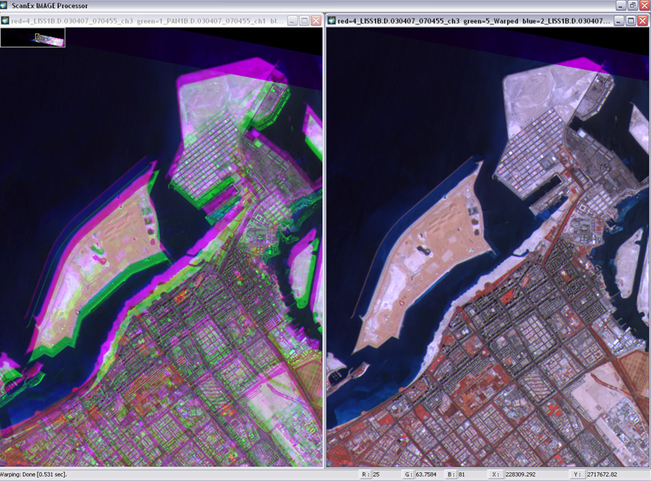
Fig 1.1: Standard processing of space borne images
Each of the pixels that represent an image stored inside a computer has a pixel value which describes how bright that pixel is, and/or what color it should be. In the simplest case of binary images, the pixel value is a 1-bit number indicating either foreground or background. For a gray scale images, the pixel value is a single number that represents the brightness of the pixel. The most common pixel format is the byte image, where this number is stored as an 8-bit integer giving a range of possible values from 0 to 255. Typically zero is taken to be black, and 255 are taken to be white. Values in between this make up the different shades of gray.
1.1 History
Many of the techniques of digital image processing, or digital picture processing as it often was called, were developed in the 1960s at the Jet Propulsion Laboratory, Massachusetts Institute of Technology, Bell Laboratories, University of Maryland, and a few other research facilities, with application to satellite imagery, wire-photo standards conversion, medical imaging, videophone, character recognition, and photograph enhancement. The cost of processing was fairly high, however, with the computing equipment of that era. That changed in the 1970s, when digital image processing proliferated as cheaper computers and dedicated hardware became available. Images then could be processed in real time, for some dedicated problems such as television standards conversion. As general-purpose computers became faster, they started to take over the role of dedicated hardware for all but the most specialized and computer-intensive operations.
1.2 Image Sampling and Quantization
To create a digital image, we need to convert the continuous sensed data into digital form. This involves two processes:
1) Sampling
2) Quantization.
The basic idea behind sampling and quantization is illustrated in Fig. 1.4 and Fig. 1.5. An image may be continuous with respect to the x- and y-coordinates, and also in amplitude. To convert it to digital form, we have to sample the function in both coordinates and in amplitude. Digitizing the coordinate values is called sampling. Digitizing the amplitude values is called quantization.
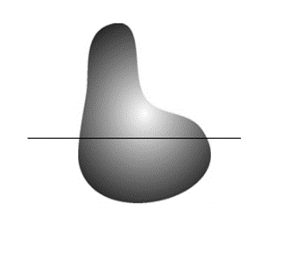
Fig 1.2 Continuous Image.

Fig 1.3 a plot of amplitude values along the line of continuous image.
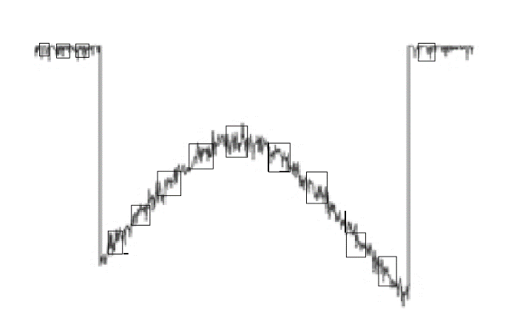
Fig 1.4 Sampling of the above continuous image.
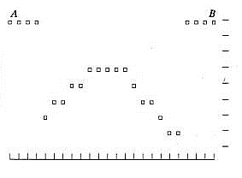
Fig 1.5 Quantization of the sampled image.
The one-dimensional function shown in Fig. 1.3 is a plot of amplitude (gray level) values of the continuous image along the line segment AB in Fig. 1.2. The random variations are due to image noise. To sample this function, we take equally spaced samples along line AB, as shown in Fig. 1.4. The location of each sample is given by a vertical tick mark in the bottom part of the figure. The samples are shown as small white squares superimposed on the function.
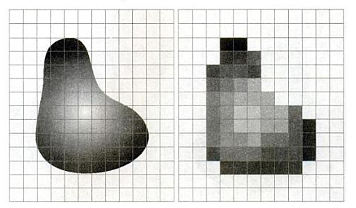
Fig 1.6 a) Continuous image projected onto a sensor array. b) Result of image sampling and quantization.
1.3 Image Representation
The result of sampling and quantization is a matrix of real numbers. We will use two principal ways to represent digital images. Assume that an image f(x, y) is sampled so that the resulting digital image has M rows and N columns. The values of the coordinates (x, y) now become discrete quantities. For notational clarity and convenience, we shall use integer values for these discrete coordinates. Thus, the values of the coordinates at the origin are (x, y) = (0, 0). The next coordinate values along the first row of the image are represented as (x, y) = (0, 1). It is important to keep in mind that the notation (0, 1) is used to signify the second sample along the first row. It does not mean that these are the actual values of physical coordinates when the image was sampled.
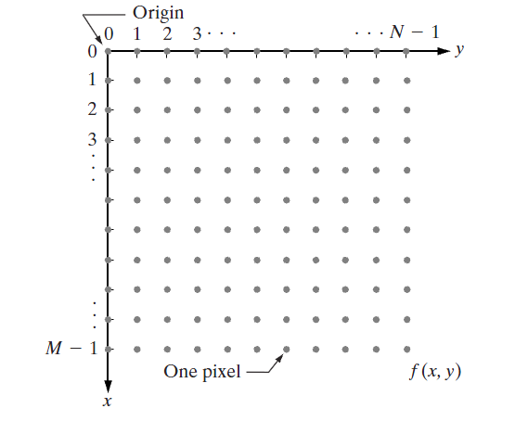
Fig 1.7 Coordinate convention to represent digital images
The notation introduced in the preceding paragraph allows us to write the complete M*N digital image in the following compact matrix form:
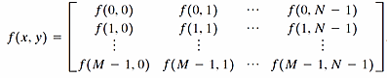
Fig. 1.8 Image in matrix form
The right side of this equation is by definition a digital image. Each element of this matrix array is called an image element, picture element, pixel, or pel. The terms image and pixel will be used throughout the rest of our discussions to denote a digital image and its elements. In some discussions, it is advantageous to use a more traditional matrix notation to denote a digital image and its elements:
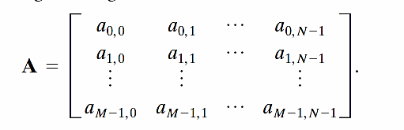
Fig 1.9 Arrays
1.4 Image Operations
1.4.1 Color depth
Image editing encompasses the process of altering images, whether they are digital photographs, traditional analog photographs, or illustrations. Traditional analog image editing is known as photo retouching, using tools such as an airbrush to modify photographs, or editing illustrations with any traditional art medium. Graphic software programs, which can be broadly grouped into vector graphics editors, raster graphics editors, and 3d modellers, are the primary tools with which a user may manipulate, enhance, and transform images. Many image editing programs are also used to render or create computer art from scratch.
1.4.2 Contrast of Image
To apply a contrast filter, you determine if a pixel is lighter or darker than a threshold amount. If it's lighter, you scale the pixel's intensity up otherwise you scale it down. In code this is done by subtracting the threshold from a pixel, multiplying by the contrast factor and adding the threshold value back again. As with the brightness filter the resulting value needs to be clamped to ensure it remains in the range 0 - 255. To apply a brightness filter you simply add a fixed amount to every pixel in the image and then clamp the result to ensure it remains in the range 0 - 255.

Fig 1.10 low contrast to high contrast

1.4.3 RGB to Gray scale
In photography and computing, a gray scale or grey scale digital image is an image in which the value of each pixel is a single sample, that is, it carries only intensity information. Images of this sort, also known as black-and-white, are composed exclusively of shades of gray, varying from black at the weakest intensity to white at the strongest. Gray scale images are distinct from one-bit bi-tonal black-and-white images, which in the context of computer imaging are images with only the two colors, black, and white (also called bi-level or binary images). Gray scale images have many shades of gray in between. Gray scale images are also called monochromatic, denoting the absence of any chromatic variation (i.e., one color).
Gray scale images are often the result of measuring the intensity of light at each pixel in a single band of the electromagnetic spectrum (e.g. infrared, visible light, ultraviolet, etc.), and in such cases they are monochromatic proper when only a given frequency is captured. But also they can be synthesized from a full color image.
1.4.4 Inverted Image
An inverted image could be interpreted as a digital version of image negatives. After inversion, every color takes the exact opposite one (I know this terminology is not that scientific, but it’s useful as a conceptual information). Let’s put this in more scientific terms. A positive image should be defined as a normal, original RGB or gray image. A negative image denotes a tonal inversion of a positive image, in which light areas appear dark and dark areas appear light. In negative images, a color reversing is also achieved, such that the red areas appear cyan, greens appear magenta, and blues appear yellow. In simpler sense, for the gray scale case, a black and white image, using 0 for black and 255 for white, a near-black pixel value of 5 will be converted to 250, or near-white.
Image inversion is one of the easiest techniques in image processing. Therefore, it’s very applicable to demonstrations of performance, acceleration, and optimization. Many of the state of the art image processing libraries such as Open CV, Gandalf, VXL etc., perform this operation as fast as possible, even though some more accelerations using parallel hardware are possible.

1.4.5 Blurring
Blurring an image usually makes the image unfocused. In signal processing, blurring is generally obtained by convolving the image with a low pass filter. In this Demonstration, the amount of blurring is increased by increasing the pixel radius.
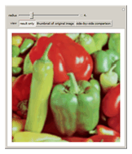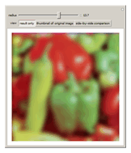
Fig 1.11 Blurring of image
1.4.6 Sharpening an Image
Sharpening is one of the most impressive transformations you can apply to an image since it seems to bring out image detail that was not there before. What it actually does, however, is to emphasize edges in the image and make them easier for the eye to pick out -- while the visual effect is to make the image seem sharper, no new details are actually created.
Fig 2.12 sharpened images

Histogram
Histograms are the basis for numerous spatial domain processing techniques. Histogram manipulation can be used effectively for image enhancement. The histogram of a digital image with gray levels in the range [0, L-1] is a discrete function h(rk) = nk, where r is the k^{th} gray level and nk is the number of pixels in the image having gray level rk. It is common practice to normalize a histogram by dividing each of its values by the total number of pixels in the image, denoted by n. Thus, a normalized histogram is given by p(rk) = nk/n, for k=0, 1,p ,L-1. Loosely speaking, p(rk) gives an estimate of the probability of occurrence of gray level rk. Note that the sum of all components of a normalized histogram is equal to 1.
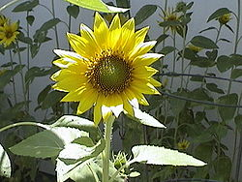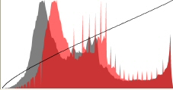
Fig 2.13 Image and its histogram
Equalization
Consider for a moment continuous function, and let the variable r represent the gray levels of the image to be enhanced. In the initial part of our discussion. we assume that r has been normalized to the interval [0, 1], with r=0 representing black and r=1 representing white. Later, we consider a discrete formulation and allow pixel values to be in the interval [0, L-1].
For any r satisfying the aforementioned conditions, we focus attention on transformations of the form s=T(r) 0 _ r _ 1
That produces a level s for every pixel value r in the original image. For reasons that will become obvious shortly, we assume that the transformation function
T(r) satisfies the following conditions:
(a) T(r) is single-valued and monotonically increasing in the interval
0 _ r _ 1; and
(b) 0 _ T(r) _ 1 for 0 _ r _ 1.
The requirement in (a) that T(r) be single valued is needed to guarantee that the inverse transformation will exist, and the monotonicity condition preserves the increasing order from black to white in the output image. A transformation function that is not monotonically increasing could result in at least a section of the intensity range being inverted, thus producing some inverted gray levels in the output image. While this may be a desirable effect in some cases, that is not what we are after in the present discussion. Finally, condition (b) guarantees that the output gray levels will be in the same range as the input levels.
Image Formats:
Raster formats:
a) Joint Photographic Expert Group (JPEG):
JPEG stands for "Joint Photographic Expert Group" and, as its name suggests, was specifically developed for storing photographic images. It has also become a standard format for storing images in digital cameras and displaying photographic images on internet web pages. JPEG files are significantly smaller than those saved as TIFF, however this comes at a cost since JPEG employs lossy compression. A great thing about JPEG files is their flexibility. The JPEG file format is really a toolkit of options whose settings can be altered to fit the needs of each image.
b) Tagged Image File Format (TIFF):
TIFF stands for "Tagged Image File Format" and is a standard in the printing and publishing industry. TIFF files are significantly larger than their JPEG counterparts, and can be either uncompressed or compressed using lossless compression. Unlike JPEG, TIFF files can have a bit depth of either 16-bits per channel or 8-bits per channel, and multiple layered images can be stored in a single TIFF file.
TIFF files are an excellent option for archiving intermediate files which you may edit later, since it introduces no compression artefacts. Many cameras have an option to create images as TIFF files, but these can consume excessive space compared to the same JPEG file. If your camera supports the RAW file format this is a superior alternative, since these are significantly smaller and can retain even more information about your image.
c) Portable Network Graphics (PNG):
PNG uses ZIP compression which is lossless, and slightly more effective than LZW (slightly smaller files). PNG is a newer format, designed to be both versatile and royalty free, back when the LZW patent was disputed. The PNG (Portable Network Graphics) file format was created as the free, open-source successor to the GIF. The PNG file format supports true color (16 million colors) while the GIF supports only 256 colors. The PNG file excels when the image has large, uniformly colored areas. The lossless PNG format is best suited for editing pictures, and the lossy formats, like JPG, are best for the final distribution of photographic images.
d) Graphics Interchange Format (GIF):
GIF is limited to an 8-bit palette, or 256 colors. This makes the GIF format suitable for storing graphics with relatively few colors such as simple diagrams, shapes, logos and cartoon style images. The GIF format supports animation and is still widely used to provide image animation effects. It also uses a lossless compression that is more effective when large areas have a single color, and ineffective for detailed images or dithered images.
e) Bitmap Format (BMP):
The BMP file format (Windows bitmap) handles graphics files within the Microsoft Windows OS. Typically, BMP files are uncompressed, hence they are large; the advantage is their simplicity and wide acceptance in Windows programs.
f) RAW:
RAW refers to a family of raw image formats that are options available on some digital cameras. These formats usually use a lossless or nearly-lossless compression, and produce file sizes much smaller than the TIFF formats of full-size processed images from the same cameras. Although there is a standard raw image format, (ISO 12234-2, TIFF/EP), the raw formats used by most cameras are not standardized or documented, and differ among camera manufacturers. Many graphic programs and image editors may not accept some or all of them, and some older ones have been effectively orphaned already. Adobe's Digital Negative (DNG) specification is an attempt at standardizing a raw image format to be used by cameras, or for archival storage of image data converted from undocumented raw image formats, and is used by several niche and minority camera manufacturers including Pentax, Leica, and Samsung.
Vector Formats:
a) Computer Graphics Metafile (CGM):
CGM is a file format for 2D vector graphics, raster graphics, and text, and is defined by ISO/IEC 8632. All graphical elements can be specified in a textual source file that can be compiled into a binary file or one of two text representations. CGM provides a means of graphics data interchange for computer representation of 2D graphical information independent from any particular application, system, platform, or device. It has been adopted to some extent in the areas of technical illustration and professional design, but has largely been superseded by formats like SVG.

b) Scalable Vector Graphics (SVG):
SVG is an open standard created and developed by the World Wide Web Consortium to address the need (and attempts of several corporations) for a versatile, scriptable and all-purpose vector format for the web and otherwise. The SVG format does not have a compression scheme of its own, but due to the textual nature of XML, an SVG graphic can be compressed using a program such as gzip. Because of its scripting potential, SVG is a key component in web applications: interactive web pages that look and act like applications

